1. The Solution is for the File Handling program given in the phase1->lesson3
2. Git URL :

<https://github.com/Yasser-Alsubhi/Yasir-Alsubhi-JFS-SDA/tree/master/Phase1/Lesson3>

1. Path :

[Yasir-Alsubhi-JFS-SDA](https://github.com/Yasser-Alsubhi/Yasir-Alsubhi-JFS-SDA)/[Phase1](https://github.com/Yasser-Alsubhi/Yasir-Alsubhi-JFS-SDA/tree/master/Phase1)/**Lesson3**/

* Copy of the code will be in the next page.
* Also, I include screen shots of the Output.

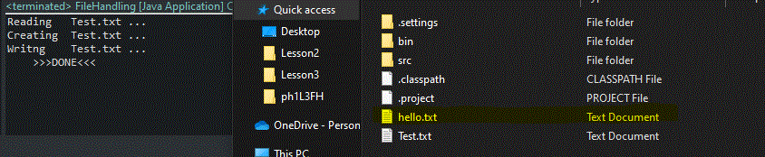

Code:

package ph1L3FH;

import java.io.FileReader;

import java.io.FileWriter;

public class FileHandling {

public static void main(String[] args) {

//in case there's some issue like the file we looking for not there

try {

//start reader for this file

FileReader reader = new FileReader("Test.txt");

// creat 'hello.txt'

FileWriter writer = new FileWriter("hello.txt");

int c = 0 ;

// to read all letters in the file

while((c=reader.read()) != -1) {

// to write letter by letter

writer.write(c);

//to insure that it will return what the writer read

writer.flush();

}

//stop read & write

writer.close();

reader.close();

// to make sure that our program make it until here and also to inform the

user about what's happening

System.out.println("Reading Test.txt ...\n"

+"Creating Test.txt ...\n"

+"Writng Test.txt ...\n"

+" >>>DONE<<<");

} catch (Exception e) {

e.printStackTrace();

// **TODO**: handle exception

}

}

}